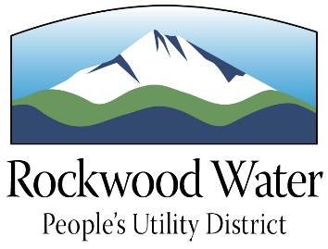
Rockwood Water People’s Utility District
Water Education Mini-Grants Program

Purpose
To supplement academic instruction by providing financial support for teachers to implement creative classroom projects that will foster greater student awareness of water and its importance.

Grant Amount
Awards will be granted in amounts up to $250 per project; a maximum of $250 will be awarded per school per fiscal year (July 1 – June 30).

Focus of Projects
Projects or teacher training must focus on water issues. They may involve sources of water, water quality, water conservation, water-related environmental or governmental issues, etc. Consider all options for your application: classroom materials, guest speakers, field trips, teacher workshops, etc.; however, the project must demonstrate direct benefit to students. Creative and unique approaches to water education are highly encouraged.

Eligibility
All K-12 educators at schools within the Rockwood Water PUD service area are eligible to apply regardless of discipline or subject areas taught. Teachers may apply individually or as a group; however the project must involve water education to be eligible.

How to Apply
Complete the grant application provided. Be sure to:
- Describe the project in detail, listing the goals and objectives, supporting activities and methods to be used to evaluate the success of the project.
- Explain the benefits that students and others will receive by participating in the project.
- Provide an itemized budget for project materials and expenses.
- Provide the required teacher and principal signatures.

Judging Criteria
Applications will be selected based on the following criteria:
- Actively engages project participants in the learning process.
- Promotes a better understanding of water and the important role it plays.
- Clearly defines student activities, goals, and objectives.
- Budget clearly supports project activities.
- Demonstrates interdisciplinary learning.
Application Deadline
Entries may be submitted at anytime; however funding is limited, so submit your application as soon as possible. Grants will be awarded throughout the fiscal year (July 1 – June 30) subject to Rockwood Water PUD approval.

Project Summary
Following project completion, grant recipients may be required to submit a project summary describing the success of the project and a final budget expense report.

For More Information
For additional information on the grant program or assistance in completing the grant application, please contact Kerry Aden, Rockwood Water PUD, at 503-665-4179 or email kaden@rwpud.org.

