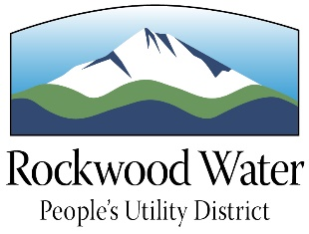

Rockwood Water People's Utility District
Water Education Mini-Grants Program

Application Form

Applicant Name(s):

School:

School Address:

City/Zip:

School Phone:

Applicant Email Address:

Grade Level:

Project Title:

Project Description:

Project Objectives:

Explain how participants will be involved in the project:

Describe the benefit of the project to participants and others:

Describe how you will measure the success of your project:

Budget (Please list project expenses in detail):

Total Amount Requested:

Teacher Signature _______________________________ Date: ___________

Principal Signature _______________________________ Date: ___________

Mail, email, deliver, or fax your completed application to:

Rockwood Water People's Utility District
Kerry Aden
19601 NE Halsey St.
Portland OR 97230
Fax: (503) 667- 5108
kaden@rwpud.org

*Application forms in Microsoft Word or PDF format can be downloaded at:

www.rwpud.org/education

