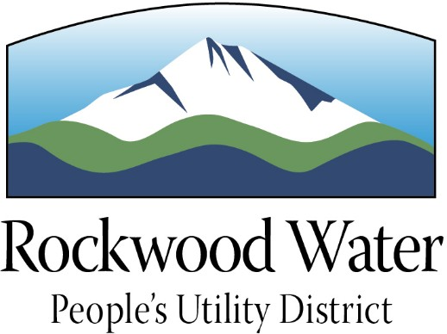

Rockwood Water People’s Utility District is seeking an experienced professional to become the District’s

GENERAL MANAGER

Anticipated Hiring Range
$145,000 to $165,000 Annually, DOE

OPEN UNTIL FILLED

First Review of Applicants October 12, 2020.
Please submit application materials at your earliest convenience.

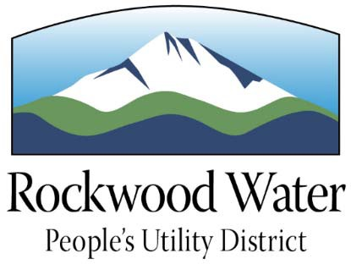
Rockwood Water People’s Utility District is a public utility service incorporated in 1925 as the Rockwood Water District. Facing annexation by the cities of Gresham and Portland, and eventual dissolution, residents voted in 1990 to create a People’s Utility District. The District serves over 65,000 residents within an approximately 10 square mile area generally bordered by Division Street to the south, I-84 to the north, 242nd to the east and 135th to the west. The District is within the cities of Portland, Gresham, and Fairview. Water for the District is sourced from the Bull Run Watershed, a surface
water supply within the Bull Run Watershed Management Unit, located in the Mt. Hood National Forest. The District’s backup water supply is sourced from the Columbia South Shore wellfield. In addition, the District has its own groundwater supply which can be used for emergencies and is normally used to augment the Bull Run water supply during the peak season and during turbidity events.
District owned infrastructure includes 165 miles of pipe, 13,654 meters, 6 pump stations, 24 pumps, 13 distribution system interties, 1,100 fire hydrants, and 2,500 valves. The District owns five wells, two of which are co-owned with the City of Gresham; the combined capacity of the District’s four reservoirs is 19.2 million gallons; and the District’s groundwater firm capacity is 15.5 million gallons per day.
Rockwood Water People’s Utility District is a self-supporting enterprise, with 2020-2021 fiscal year appropriations of ~$22,000,000 Million. Most of the District’s revenues are generated by water sales and associated services.
The District has paid particular attention toward customer satisfaction, with its first customer attitude survey undertaken in partnership with the Portland State University Research Center in 2013. The results of the survey showed a high level of customer trust in the District, which the District continues to strive to maintain.
Rockwood Water People’s Utility District is governed by a five-member Board of Directors, elected by subdivisions, to overlapping four-year terms of office. The Board of Directors establishes policies for the District and its operations and appoints the General Manager, who is charged with administering policies adopted by the Board. The Board meets monthly at the district office, located at 19601 NE Halsey Street in Portland.
THE ORGANIZATION
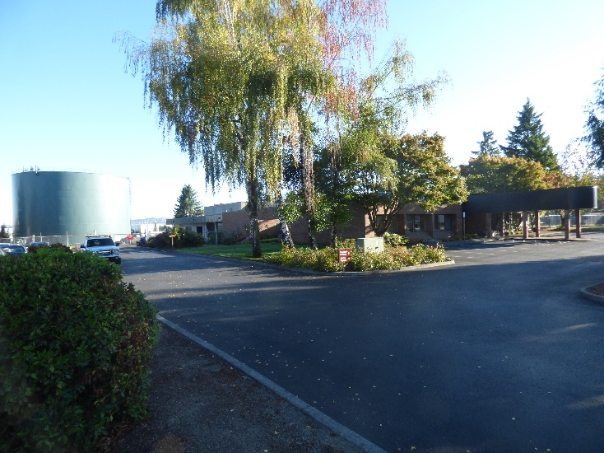
The District is organized into four units: Business Operations & Customer Service; Operations, Maintenance, & Construction; Accounting; and Engineering. The General Manager’s office is charged with leading the District’s conservation efforts. District staff operate and maintain the water system; design projects and perform construction management; read meters; bill for service and collect payments; develop budgets, set rates, and account for District finances; and provide service to District customers. The General Manager oversees all staff operations performed by the District’s staff of 24 FTEs, approximately 17 of whom are represented by AFSCME.

The General Manager serves as Chief Executive Officer of the District and is responsible for the administration and implementation of the District's policies and programs as adopted by the Board of Directors. The General Manager serves at the pleasure of the Board of Directors and is responsible to plan, lead and direct the operations of the District in order to ensure compliance with all applicable laws and statutes, District goals and policies, and regulations. The General Manager oversees day to day operations of the District to ensure the provision of high quality, cost effective drinking water service and is accountable for achieving the goals and objectives established by the Board in a manner consistent with Board-adopted policies, mission and values. The General Manager is responsible for District planning, financial management and human resources administration.

Specific duties include:

- Plans, directs and manages all District operations, including water supply and distribution, water quality and regulatory compliance, financial management, budgeting, rate setting, planning, project implementation, human resources, operations and maintenance, safety, asset management, intergovernmental relations, conservation and all District functions.
- Oversees all aspects of human resources management including hiring and firing, disciplinary process, employee evaluations, ensuring compliance with HR policies and the collective bargaining agreement, negotiating as the Board’s agent the collective bargaining agreement, payroll, and salary administration.
- Manages the annual budget process including working with the Board to establish goals, objectives and key performance indicators; developing the budget and leading the process through Board adoption; development of rates, charges and fees for service; updating the Financial Plan annually; developing annual revenue and expenditure plans and reporting on status to the Board monthly; ensuring that all financial transactions conform to the Budget, financial plan, and all applicable laws, statutes and regulations.
- Leads and directs the development and implementation of all District planning activities, including: Financial Plan, Master Plan, Water Conservation and Management Plan, Asset Management Plan, Strategic Plan, Capital Improvement Plan, annual District Work Plan, and provides status reports to the Board periodically regarding Plan implementation.
- Ensures all procurements (professional services, materials and services, capital projects) meet applicable statutes, laws, and regulations.
- Represents the District with other governments and stakeholders, including the Regional Water Providers Consortium, Water Managers Advisory Board, Neighborhood Associations, professional associations, State legislature.
- Continuously undertakes organization development activities to improve the efficiency and effectiveness of the District.
- Establishes communication protocols to connect with all District customers and stakeholders such as meetings and outreach, website, brochures, mailers, bill stuffers, newsletters, customer surveys, public meetings, community-televised Board meetings.
- Promotes internal communication, information sharing and employee involvement in problem solving and improvement.
- Ensures the emergency preparedness of the District and fosters and promotes a culture of Safety.
- Monitors and reports District performance on a regular basis.
- Ensures the District has a productive, multi-faceted Conservation program.
- Undertakes analyses for the Board as appropriate.
- Communicates regularly and as needed with the Board of Directors. Ensures the Board is informed about District matters and is prepared with helpful packets prior to Board meetings.

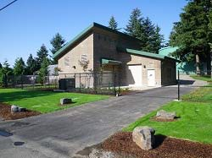
The General Manager must be a visionary, with the ability to facilitate development and implementation of strategic plans based on Board policy direction, and Master and Financial Plans. The position requires superior communication skills with a customer service focus, the ability to build consensus around complex and divisive issues, and the ability to mediate and resolve controversial problems. The General Manager must have a solid understanding of business principles and management practices, and have experience implementing accepted principles and practices of public budgeting and financial reporting. The position is required to build and maintain strong, positive working relationships with the Board of Directors, District staff, the general public, and other agency representatives. The General Manager must be a good listener with demonstrated success working collaboratively to effectively implement Board goals and policies, and to effectively monitor achievement of those goals. The General Manager must have demonstrated ability to maintain, develop and nurture cooperative working relationships with various government entities, and be visible within the District, with statewide organizations, and with other associations/key partners.
MINIMUM REQUIREMENTS
A typical way to obtain the knowledge, skills and abilities would be:
  - A Bachelor’s Degree in public administration, business administration, engineering, or related field; AND five
(5) years’ senior management experience.
  - OR, any equivalent combination of education, training, and/or experience that would likely provide the knowledge, skills, and abilities to successfully perform the essential functions of the position.

  - A Master’s Degree and experience at a water or public works utility are preferred.

NECESSARY SPECIAL REQUIREMENTS
  - Must possess a valid Driver License accepted in the State of Oregon, with an acceptable driving record.
  - A background check will be conducted on the finalist for this position.
• and abilities to perform the duties of the position.
COMPENSATION & BENEFITS
Rockwood Water People’s Utility District offers a generous compensation and benefits package. The anticipated hiring range for this position is $145,000 to $165,000 annually, dependent on the experience and qualifications of the successful candidate.

Benefits include:

    - Group medical, dental, and vision coverage for employees and eligible dependents

    - Employer-paid life and long-term disability insurance

    - HRA VEBA
  - Participation in the Oregon Public Employees Retirement System (PERS)

  - Paid Time Off (PTO)

  - Paid holidays

To be considered for this position, please return the following to Rockwood Water People's Utility District:
    - A fully completed and signed employment application,
    - Cover letter,
    - Resume (maximum 5 pages), and
    - Answers to the supplemental questionnaire. Answers should be a maximum of 300 words per question.
Preference will be given to honorably discharged veterans and disabled veterans of the United States Armed Forces. To receive veterans’ preference, please complete the veterans’ preference form, including attachment of required materials, and submit with your applications materials.

Interested applicants must submit all application materials to be considered. Visit https://rwpud.org/employment for application materials and instructions.

Application materials can be mailed, faxed, or emailed to:
Rockwood Water People's Utility District
19601 NE Halsey Street
Portland, Oregon 97230
Fax: 503.667.5108
bstahl@rwpud.org

Please direct questions about this position to Brian R. Stahl, General Manager, Rockwood Water People's Utility District at 503.665.4179 or bstahl@rwpud.org.

EQUAL EMPLOYMENT OPPORTUNITY: Rockwood Water People’s Utility District will give consideration to all qualified applicants for appointment without regard to race, religion, color, national origin, sex, age, marital status, mental or physical disability, political affiliations, sexual orientation, or any other non-merit factor. To ensure the broadest range of services to individuals with disabilities, Rockwood Water People’s Utility District is prepared to make necessary arrangements. Please call at least two (2) working days in advance for services.

